Unprimed Self Operated Pump
Abstract:-
Hydraulic ram pumps are water-lifting devices that are powered by filling water. Such pumps work by using the energy of water falling a small height to lift a small part of that amount of water to a much greater height. In this way, water from a spring or stream in a valley can be pumped to a village or irrigation scheme on the hillside. The main and unique advantage of hydraulic ram pumps is that with a continuous flow of water, a hydraulic ram pump operates automatically and continuously with no other external energy source - be it electricity or hydrocarbon fuel. It uses a renewable energy source (stream of water) mid hence ensures low running cost. It imparts absolutely no harm to the environment Hydraulic ram pumps are simple, reliable and require minimal maintenance. All these advantages make hydraulic ram pumps suitable to rural community water supply mud backyard irrigation in developing countries. In this paper, different aspect of designing a hydraulic-rain pump system is discussed. Application and limitation of hydraulic-ram pump is presented. Alternative technologies which compete with hydraulic ram pump are highlighted. Finally, the Research, Development and Technology Adaptation Center (RDTAC) work on hydraulic-rain pump is presented and discussed.

Introduction: -
Hydraulic Rams are impulse pumps which utilize the momentum of falling and power is derived from the water hammer that is intentionally produced. They are used in small water supplies where relatively large amounts of water at moderate heads are available, such as rivers or streams with rapid falls, where the pumps can be installed. The force of water is captured in a chamber where the compressed air expands, pushing a small quantity of water to a higher elevation than that from which it originally came. The water enters an inclined pipe called drive pipe. The delivery valve is closed at this time stage but the water starts escaping through the opening in another valve is called ‘impetus valve’ ; the water gain more and more velocity and the rush of water close the impetus valve fully. At this stage, the water current is suddenly stopped and this exerts a great impulse or pressure due to water hammer on the delivery valve which opens and the water enters the air chamber and starts going up the delivery pipe to its destination like tank. The cycle of process is repeated. The ram should be located at a lower level than the source of water so that a natural fall is obtained to develop the velocity at the impetus valve.

Ram Pumps have been used for over two centuries in many parts of the world. Their simplicity and reliability made them commercially successful, particularly in Europe, in the days before electrical power and the internal combustion engine become widely available. As technology advanced and become increasingly reliant on sources of power derived from fossil fuels, the ram pump was neglected. It was felt to have no relevance in an age of national electricity grids and large - scale water supplies. Big had become beautiful and small-scale ram pump technology was unfashionable. In recent years an increased interest in renewable energy devices and an awareness of the technological needs of a particular market in developing countries have prompted a reappraisal of ram pumps. In hilly areas with springs and streams, the potential for a simple and reliable pumping device is large. Although there are some examples of successful ram pump installation in developing countries, their use to date has merely scratched at the surface of their potential.

Principle of Water Hammer: -
When the water hits the closed tap, a pressure wave is propagated back into the flowing water, halting any motion as it arrives. When the pressure wave reaches the end of the flowing water, say a distance L away, all the water has been stopped. The wave then reflects from this end, according to the arrangements there, and returns down the pipe, reaching the tap at time t = 2L/c. It is again reflected, and the same thing happens. All the kinetic energy of the water has been transformed into the energy of a wave, which bounces back and forth. The regular arrivals are like the blows of a hammer, and the phenomenon is called water hammer.

How a Hydraulic Ram Pump works: -
The concept behind the ram idea is a "water hammer" shock wave. Water has weight, so a volume of water moving at a certain speed has momentum - it doesn't want to stop immediately. If a car runs into a brick wall the result is crumpled metal. If a moving water flow in a pipe encounters a suddenly closed valve, a pressure "spike" or increase suddenly appears due to all the water being stopped abruptly (that's what water hammer is - the pressure spike). If you turn a valve off in your house quickly, you may hear a small "thump" in the pipes. That's water hammer.

Here's how the hydraulic ram pump actually works, step-by-step:
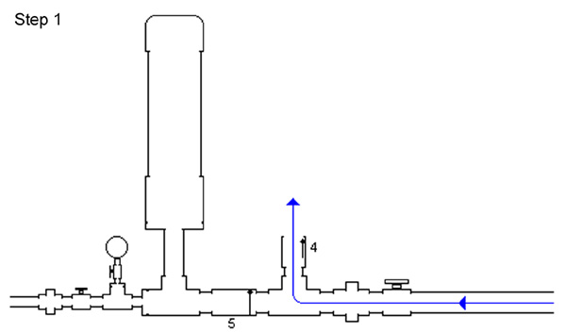
(1) Water (blue arrows) starts flowing through the drive pipe and out of the "waste" valve (#4 on the diagram), which is open initially. Water flows faster and faster through the pipe and out of the valve.
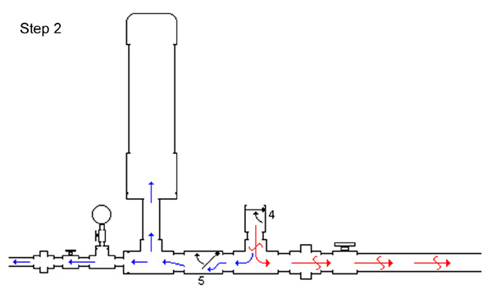
(2) At some point, water is moving so quickly through the brass swing check "waste" valve (#4) that it grabs the swing check's flapper, pulling it up and slamming it shut. The water in the pipe is moving quickly and doesn't want to stop. All that water weight and momentum is stopped, though, by the valve slamming shut. That makes a high pressure spike (red arrows) at the closed valve. The high pressure spike forces some water (blue arrows) through the spring check valve (#5 on the diagram) and into the pressure chamber. This increases the pressure in that chamber slightly. The pressure "spike" the pipe has nowhere else to go, so it begins moving away from the waste valve and back up the pipe (red arrows). It actually generates a very small velocity *backward* in the pipe.
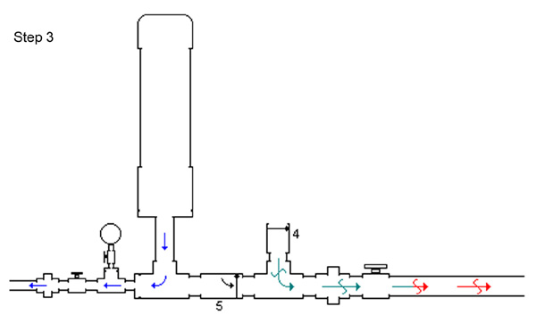
(3) As the pressure wave or spike (red arrows) moves back up the pipe, it creates a lower pressure situation (green arrows) at the waste valve. The spring-loaded check valve (#5) closes as the pressure drops, retaining the pressure in the pressure chamber.
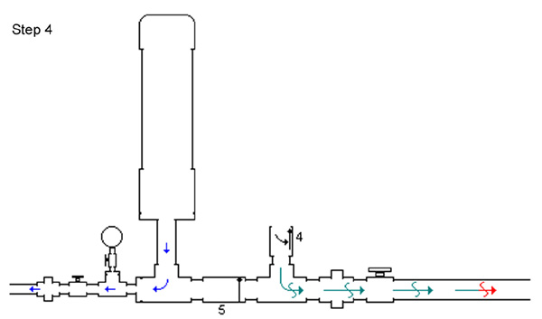

(4) At some point this pressure (green arrows) becomes low enough that the flapper in the waste valve (#4) falls back down, opening the waste valve again.
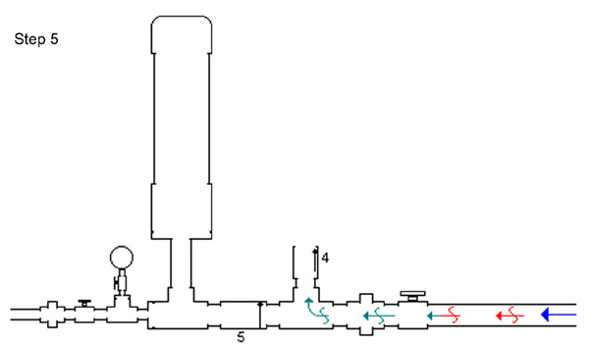
(5) Most of the water hammer high pressure shock wave (red arrows) will release at the drive pipe inlet, which is open to the source water body. Some small portion may travel back down the drive pipe, but in any case after the shock wave has released, pressure begins to build again at the waste valve (#4) simply due to the elevation of the source water above the ram, and water begins to flow toward the hydraulic ram again.
(6) Water begins to flow out of the waste valve (#4), and the process starts over once again.
Steps 1 through 6 describe in layman's terms a complete cycle of a hydraulic ram pump. Pressure wave theory will explain the technical details of why a hydraulic ram pump works, but we only need to know it works.(One American company has been manufacturing and selling hydraulic rams since the 1880’s). The ram pump will usually go through this cycle about once a second, perhaps somewhat more quickly or more slowly depending on the installation.
Each "pulse" or cycle pushes a little more pressure into the pressure chamber. If the outlet valve is left shut, the ram will build up to some maximum pressure (called shutoff head on pumps) and stop working.

Advantages:-
- It is quite efficient for lifts up to 30 meters.
- No electrical power or any other prime mover is necessary.
- Once the ram is started, need little attention and works 24 hours a day with no operating cost and practically no maintenance; usually lasts for more than 30 years with packing changed every year.
- Durable, reliable and inexpensive in initial cost.

Conclusion:-
The following conclusions can be made from RDTAC's project work on Hydraulic Ram pumps.
- There is broad prospect of utilizing the country's abundant surface water run off potential for various purposes or requirements using locally designed and manufactured hydraulic ram pumps and other similar appropriate technologies.
- To disseminate hydrams at potential sites throughout the country, there is a need to create awareness through training and seek integrated work with rural community, government institutions like water, energy and mines bureau of local regions and non-governmental organizations.
- Hydraulic Ram pumps made by casting have many advantages, but they could be expensive. In addition, considering the cost of civil work and pipe installation, the initial investment could be very high. To reduce cost of hydrams made by casting, there is a need for standardization. Standardizing hydram pump size will also have an advantage to reduce cost of spare parts and facilitate their easy access when they are needed.
- The use of appropriate means of treating river water should be looked at in conjunction with any development project of domestic water supply using hydrams.

